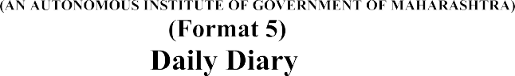


Name of industry: MOUNTREACH SOLUTION PVT. LTD.

Address of Industry: VQX7+JG, Dastur Nagar, Amravati, Maharashtra (444607).

Duration: From………………..To…………………..

Name of Industry Personnel: Mr. Nikhil Shende.

Designation Of Industry Personnel: CEO and Founder.

I.Code & Name of the Student: (22CM010) Naman S. Bharsakale.

Name of Programme: Computer Engineering.

(Special instructions to students:
- Write down the daily activity on the same day.
- Make note of the important actual activity/ies only.
- Summarize at the week -end.
- Add the extra sheets if needed for daily or weekly activity report.)



